IAM TASKS
- Create one IAM user and assign EC2 and S3 full access roles.
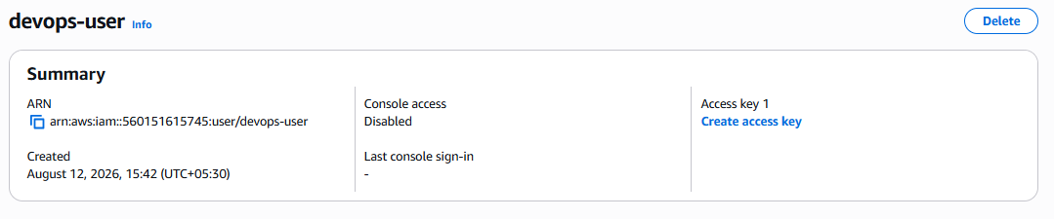
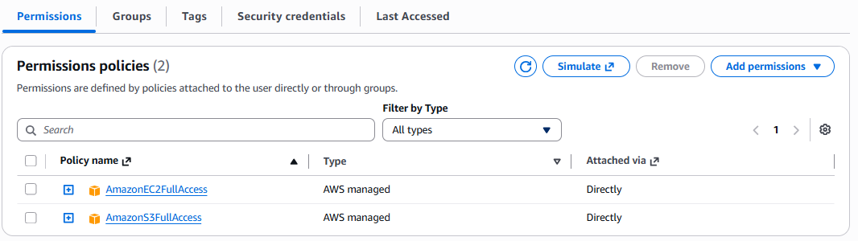
- Create one group in IAM and assign read access for EC2.
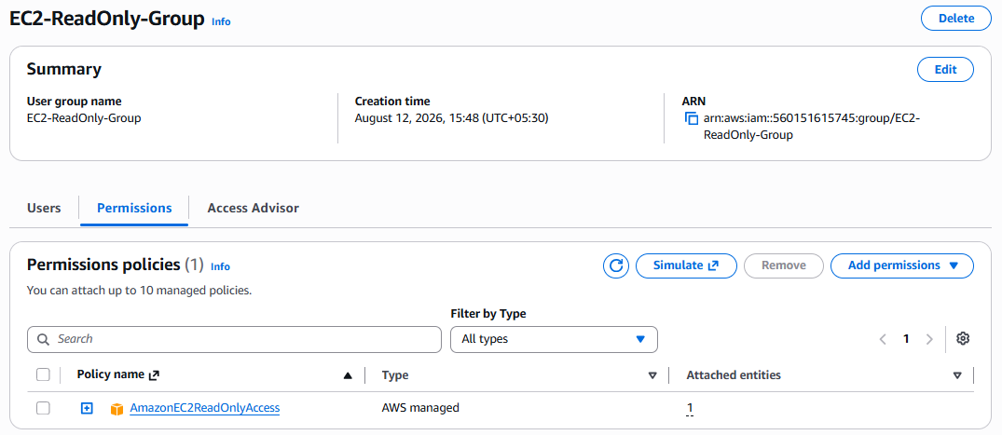
- Create a new user named "Devops" and add to the group created in task 2.
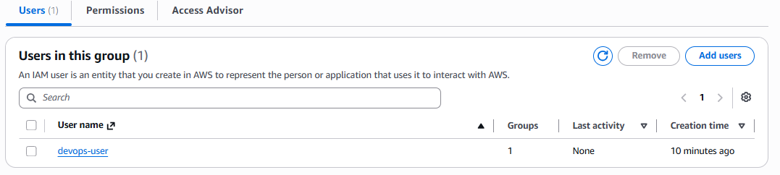

- Write a bash script to create an IAM user with VPC full access.

#!/bin/bash

USER_NAME="Devops-VPC-Admin"

# Create IAM user
aws iam create-user --user-name "$USER_NAME"

# Attach AWS managed VPC full-access policy
aws iam attach-user-policy \
--user-name "$USER_NAME" \
--policy-arn arn:aws:iam::aws:policy/AmazonVPCFullAccess

echo "IAM user '$USER_NAME' created with VPC full access."

- Create an IAM policy to allow EC2 access for a specific user in specific regions only.
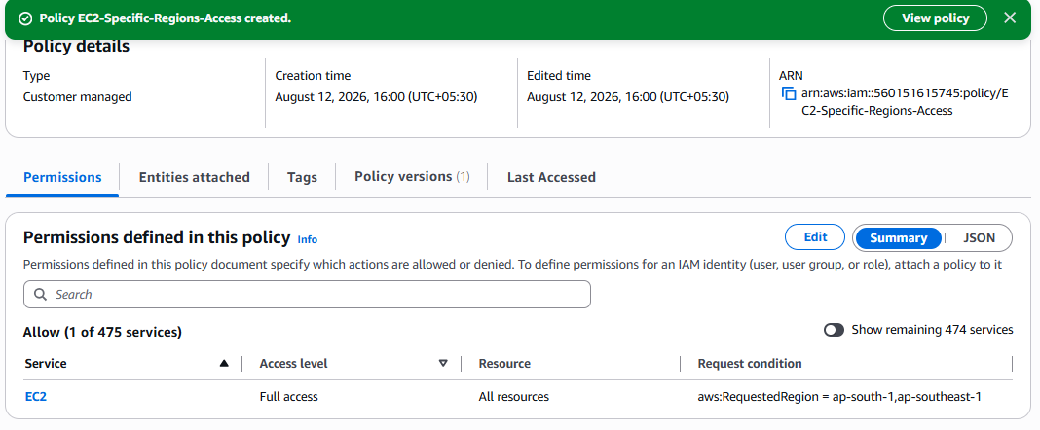
6. We have two accounts: Account A and Account B. Account A user should access an S3
bucket in Account B.
(Collaborate with a team member and execute this. This is mostly asked in every
interview.)

